Not completely accurate, but you see where this is going. The green stuff is the chain, the specific transactions within the chain are listed below. We can make it so that you can’t move to the next green/blue stage without completing the sub stage transactions. The participants and assets for each stage are lined up with the flow, so it’s easier to conceptualise it.

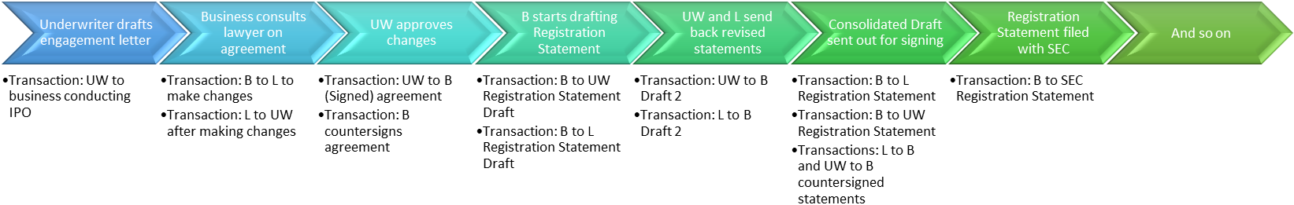

Asset:

Process flow:

Participants:

